Final Year Project Report
Full Unit – Final Report

Design of an Efficient and Reliable Multicast Protocol for IEEE 802.11n WLANs

Ahmed Mehfooz

Amna Abid

Shanzae Nadeem Khan

A report submitted in part fulfilment of the degree of
BSc (Hons) in Computer Science

Supervisor: Supervisor Name

Department of Computer Science
Lahore University of Management Sciences

Declaration
This report has been prepared on the basis of my own work. Where other published and unpublished source materials have been used, these have been acknowledged.

Word Count:

Student Name: Ahmed Mehfooz, Amna Abid, Shanzae Nadeem Khan

Date of Submission: 9th May, 2015

Signature:
Table of Contents
Abstract 3
Acknowledgements 4
Chapter 1: Introduction 5
1.1 Background Motivation 5
1.2 Aims and Objectives 6
1.3 Experimental Evaluation of Multicast Performance in stock 802.11 7
Chapter 2: Understanding Multicast in 802.11 9
Chapter 3: The Kernel Module 10
3.1 Introduction 10
3.2 Hook 10
3.3 Rate Adaptation Mechanism 11
3.4 Leader Selection Protocol 12
Chapter 4: Experimental Evaluation 14
4.1 The Test-Bed Topology 14
4.2 Throughput Comparison of ACK Intervals 14
4.3 Throughput Comparison for Different Bit Rates 15
4.4 Throughput Comparison of Leader Correction with no Leader Correction 16
Chapter 5: Project Checklist 17
Chapter 6: Related Works 18
6.1 Reliable and Efficient Multicast Protocol (REMP)[1] 18
6.2 Double Piggy-Back Mode Multicast (DPMM)[2] 18
6.3 Batch Mode Multicast Protocol (BMMM)[3] 19
6.4 Connectivity-Based Reliable Multicast MAC Protocol[4] 19
Chapter 7: Future Venues 20
References 21

Abstract
IEEE 802.11 based wireless local area networks, referred to as WiFi, have been globally deployed and a large majority of mobile devices are currently WiFi enabled. Many applications, including media streaming and video conferencing, require copies of the same packet to be transmitted to multiple destinations. Therefore, multicast if more suitable for these applications as compared to unicast because unlike unicast, multicast transmissions eliminates inefficient delivery of duplicate packets by concurrent broadcasts of one packet to multiple destinations.
Unfortunately, the current implementation of 802.11n WLANS rudimentary support for multicast transmissions. It allows sending at the base rate (1 Mbps) with no error recovery mechanism. In its current implementation, multicast over WiFi is not useful for several potentially beneficial use cases e.g. real time video streaming.
Our project implements a Rate Adaptation Protocol to improve multicast performance in WiFi which improves real time application performance by an order of magnitude. Additionally, we carried out an extensive literature survey on work that has already been carried out in this venue, hence, further optimizing their implementations of improving reliability in multicast.

Acknowledgements
We would like to thank the following people for their help in the production of this project:
Dr Ihsan Ayyub Qazi, project supervisor, without whose constant guidance, support and unlimited encouragement, this project would not have reached its aspired goal.
Dr Asim Karim, and Dr. Sohaib, our project committee members, without whose intellectual and thought provoking discussions within the project meets enables us to expand our horizon and ideas regarding the possibilities the project could accomplish.

Introduction

Background Motivation
Recent years have witnessed a rapid growth of mobile devices such as smart-phones and tablets equipped with wireless local area network (WLAN) interfaces that use WiFi standards. While these devices allow users to access the Internet anywhere anytime, it is not straightforward to serve rich multimedia content, such as real time video streams, when users are clustered in crowded areas, due to a combination of high bandwidth requirements, shortage of wireless spectrum and no transmission guarantees.
Multicast is a highly attractive solution for applications such as live video streaming because it allows the efficient usage of a Local Area Network by multiple clients. This efficient usage can be extremely useful in wireless networks as a large number of nodes contending for the channel can otherwise cause significant performance drops. Multicast can enable multiple nodes to receive a video stream with a single transmission from the access point (AP). However, Multicast in 802.11 has several challenges associated with it. It is not possible to send at high data rates if there are nodes present with poor link qualities. In such a scenario, the AP is forced to transmit packets at a lower bitrate in order to cater the poor quality link recipients as well. To simplify the implementation in the 802.11 standard, multicast packets are always transmitted at the base rate. This is in part because gathering feedback in multicast is considerably harder than feedback for unicast transmissions. As a result, Multicast transmissions in 802.11 do not require any feedback to reduce overhead. Without feedback it is impossible to implement a rate control algorithm for multicast in 802.11 which is another reason for transmissions being limited to the base rate in multicast. Lack of feedback also means that frame aggregation is not possible as it requires block Acknowledgements. Frame aggregation is an essential feature that greatly increases the efficiency of channel accesses in wireless networks, thus it is instrumental in improving throughput in high speed wireless networks. The key problem is to add feedback to multicast in 802.11 without incurring large overhead and then utilizing this feedback to design an effective rate control algorithm. The feedback implemented should also ideally be able to implement support for frame aggregation.
To conclude, there are many features of 802.11n that while unicast enjoys, multicast is missing out on, including high transmission rates of up to 300 Mbps, reliable transmissions due to feedback mechanisms and higher throughput using frame aggregation. Hence, there is immense room for optimization in the current multicast implementation.

Aims and Objectives
The main objectives of our project:
- Identify the problems faced by the current implementation of multicast in 802.11 wireless LANs.
Conduct experiments to compare the performance of multicast with that of unicast transmissions.
- Research and study of the previously occurring solutions to this problem of Multicast.
Conduct a comprehensive literature review of the already occurring protocols and classified them accordingly.
- Identify the trade-offs involved in the proposed solutions and to come up with the best possible solution.
We concluded that there is a trade-off between reliability and performance of the multicast solutions. Higher reliability meant increased overhead due to increased feedback.
- Maximize performance of the multicast transmission while incurring the least amount of overhead.
We plan to design an efficient rate control mechanism utilizing feedback to avoid sending at the lowest possible rate.
- An in-depth analysis of the Wireless Driver code in order to adjust the rate of the multicast packets, such as ath9k and MAC 802.11.
Based on our analysis we intend to change the rate at which multicast packets are send out and conduct experiments to confirm the changes made.
- Design a Rate Adaptation algorithm that probabilistically probes the available rates to choose the best possible rate at that signal strength.
Plan to design a rate adaptation that takes the weighted average of the PER rate and the RSSI values to adjust the multicast rate.
- Design an efficient leader-based protocol to avoid excess overhead and making it reliable at the same time.
To come up with a protocol where the leader sends ACK after the reception of a certain number of packets.

Experimental Evaluation of Multicast Performance in stock 802.11

- Topology of Experimental Setup
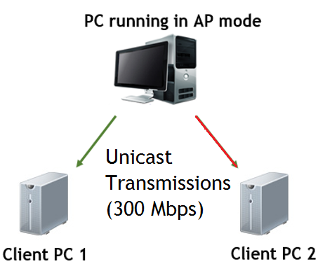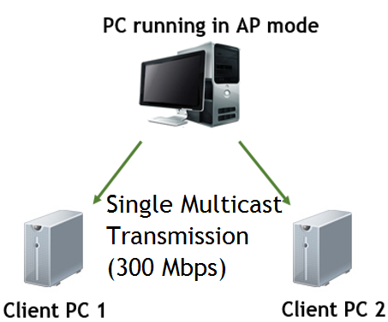

- Hardware/Software Specifications
Operating system – Linux 14.04
Wireless Driver – Ath9k
Atheros Wireless Card

- Experimental Results

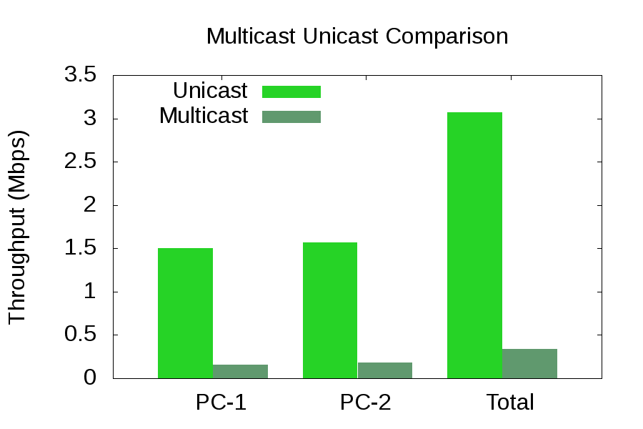

Using the topology given in the above diagrams we compared the throughput of unicast and multicast transmissions. According to the results of the experiments as given in the graph above, the throughput of multicast if many times worse than that of unicast due to the limitations it suffers as mentioned in the previous section. Hence, there is a lot of room for optimization possible in the current multicast implementation in stock 802.11 WLANs.

Understanding Multicast in 802.11
In order to begin with our project, we needed to understand the current multicast implementation in the ath9k driver. Therefore, using the software Understand we delved into the driver code to follow the path of how a multicast packet is created, transmitted and received. We made many configurations in the driver code in order to thoroughly trace the entire path that a multicast packet takes during its transmission. We built an interface on the driver to enable us to manually change the bit rate of the multicast packet’s transmission by creating a debugfs entry in the driver code. Once we successfully implemented that interface on the driver, we needed to develop a system to be able to easily change the bit rate of the packet whenever and however we preferred without having to go back into the code. For this purpose we implemented a kernel module on top of this interface.
This kernel module could then also be utilized to implement the Rate Adaptation Protocol and the Leader Selection Protocols into the current multicast implementation.

The Kernel Module

Introduction
There are two kernel modules; the client module and the serer module. The server module uses the IP tables to mangle packets and adds information to the packet that needs to be conveyed to the clients e.g. current leader, current rate index. On the other hand, the client module uses hooking to count the number of multicast packets that are being received. This allows the client to send feedback to the server.

Hook

Hooking is a method of code injection in an active LINUX kernel. Our hook sits between the Physical Layer and the Wireless Driver of the Client. The hook is capable of intercepting the packets associated with a single multicast group. It counts the number of multicast packets that are being received by the Client from the Server, hence, enabling periodic feedback response from the Clients containing PER and RSSI values.

Rate Adaptation Mechanism
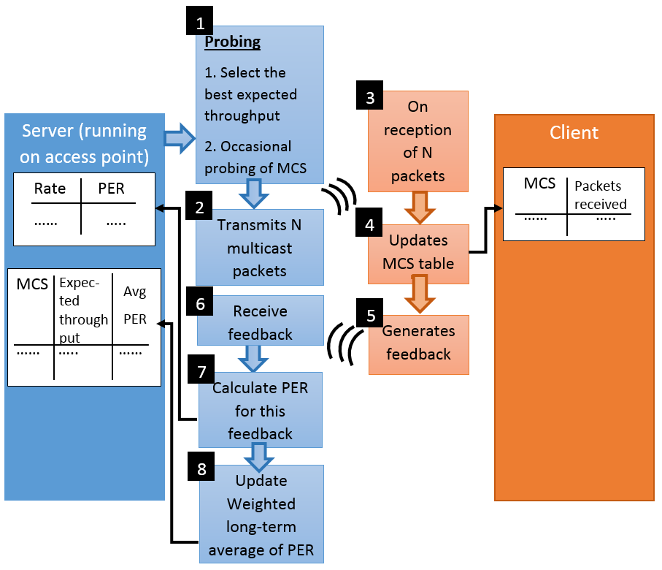
Rate Adaption involves choosing the best possible rate for the given channel conditions. In the current implementation of multicast, data is transmitted at a very low rate (1 Mbps) which degrades the overall system throughput. Moreover, the high speed senders with better channel conditions suffer due to this low rate. A rate adaptation algorithm needs to be designed that caters for the varying channel conditions and chooses that optimal rate. It is challenging to select the optimal rate as a very high rate would starve the sender with poor channel conditions and a low rate would make the high speed senders suffer as they wouldn’t be fully utilizing the system bandwidth.
As described in the diagram above, at the server side, the algorithm begins by selecting the best expected throughput for the given channel conditions. It then transmits a configurable number of N packets at this rate to the client. The Client at the reception of these N packets updates its table entries. For every MCS rate it updates the number of packets received in this transmission. It then generates a feedback which contains the table entries of the all the MCS and the corresponding number of packets received. Server after receiving this feedback calculates the PER for this feedback. Using this PER it then computes the long-term weighted average of PER which is further used to calculate the expected throughput. The MCS with the highest expected throughput is selected. Occasional probing is done two rates above and below the selected MCS for further optimization.
As mentioned above a configurable number of N packets is send at a time. We observe that a very low value of N results in a very low system throughput due to the increase in overhead. However, with increasing values of N we see an increasing trend in the overall system throughput till a certain value of N after which the throughput declines. After this point the system becomes less responsive to changes in the value of N and so results in throughput degradation. This mechanism is further elaborated in the experimental evaluations below.

Leader Selection Protocol
Leader Selection involves selecting a node with the worst channel conditions in the multicast group. This node is responsible for sending feedback on behalf of the group. As it the node with the worst link quality, it is assumed that all the other nodes have received the transmitted data. In previous works like REMP, leader selection process was repeated after every packet drop which introduced a huge amount of overhead. Our leader selection process to our knowledge is very different from the previously implemented leader selection algorithms. It relies on overhearing the feedback sent by the leader node to compare the channel conditions of multiple nodes. It’s entirely distributed and can be scaled to large number of nodes as the access point is not responsible for selecting the leader in the multicast group.
The process starts off by selecting the leader at random and overtime the node with the worst channel condition becomes the leader. After a configurable amount of packets have been received the nodes, the leader sends acknowledgments indicating the correct number of packets received. The non-leader nodes overhear this transmission and compare their correctly received packets to those received by the leader. If the number of correctly received packets by the non-leader is less than 90 percent of the correctly received packets by the leader, the non-leader sends a takeover message to access point. Otherwise it continues with its overhearing the ACKs to monitor the channel conditions as explained in the flow chart below.
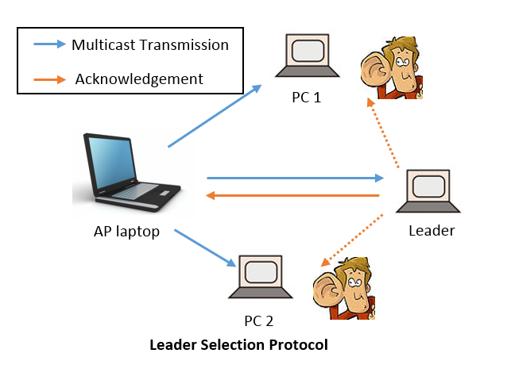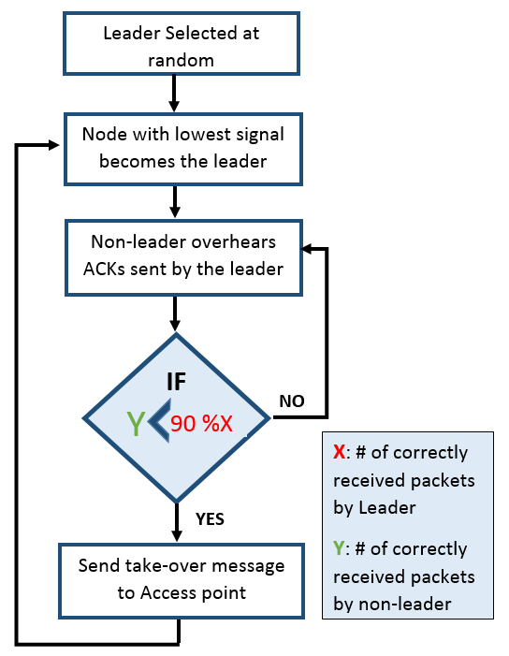

Experimental Evaluation

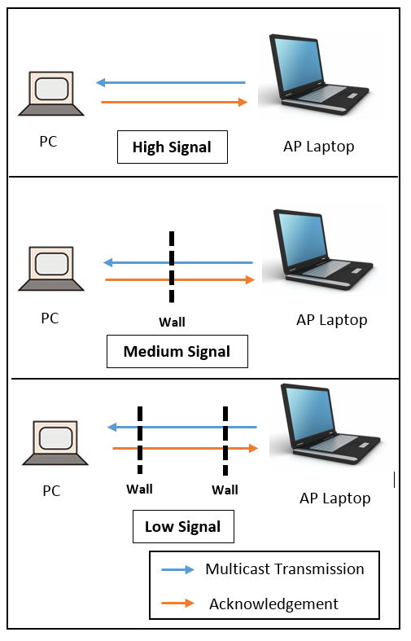
The Test-Bed Topology

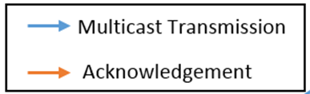

As shown in the above diagrams, our experimental test-bed consisted of three different scenarios, based on the signal quality of the multicast transmission between the PC and the AP laptop. We discarded the results of the Low Signal scenario because for every index rate in that scenario, the error rate was above 95% hence giving very low throughput.
For every scenario in every experiment, we have calculated the MAC Layer throughput by counting the number of packets received at each client.

Throughput Comparison of ACK Intervals

In this experiment we are trying to explore the optimum approximate interval (number of packets received by the Client) after which feedback should be sent by the client to the server. According to our results, the optimum interval in ~50 packets as it gives the highest throughput in both high and medium signal scenarios.

Throughput Comparison for Different Bit Rates

In this experiment we are comparing the performance of multicast at different rates in the absence on probing with that of multicast in the presence of probing. According to our results the throughput of multicast transmissions improves significantly when probing is integrated into it in both High and Medium Signal Scenarios.

Throughput Comparison of Leader Correction with no Leader Correction
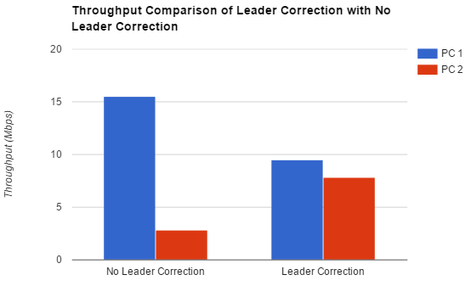
In this experiment we are comparing the performance of multicast with no leader correction with that of leader correction using our Leader Selection Protocol. According to our results, fairness in throughput increases when the correct leader with the lowest link quality) is chosen. Both the PCs get a fair amount of throughput instead of using the wrong leader (with a higher link quality), hence choosing a higher bitrate and making the poor link quality PC suffer.

Project Checklist

Month | Deliverable
October | - Literature Review  - Brainstorming on possible solutions
November | - Driver code evaluation  - Test-bed setup  - Experiments to evaluate stock 802.11 multicast performance
December | - Exploring for the most viable method to passively get feedback from receivers. Will require extensive experiments on the test-bed and driver code analysis. (According to the results the methods proved to be unsuitable for multicast hence a new approach needed to be adopted.)
February | - Developing a viable feedback mechanism to provide rate control for multicast transmissions using hooking.
March | - Developing the Rate Adaptation Protocol using probing.
April | - Developing the Leader Selection Protocol using the ACK overhearing method.
May | - Carrying out experiments to observe the magnitude of improvement in multicast transmissions by implementing the aforementioned protocols in multicast 802.11.

Related Works
Prior works on multicast protocols can be broadly categorized into Leader and non-Leader based protocols. This can further be subdivided into ACK-based and NACK-based protocols. All the protocols aim at making multicast more reliable and efficient while keeping in mind the trade-off between the two. High reliability requires more feedback which incurs a higher overhead. On the other hand, High performance requires less feedback to increase throughput which results in less reliability.

Reliable and Efficient Multicast Protocol (REMP)[1]
Leader-based protocols like Reliable and Efficient Multicast protocol (REMP) usually select the node with the worst quality as the leader and the leader is responsible for sending feedback on behalf of the group. Leader selection process adds substantive overhead as a new leader is selected whenever a new node joins, a leader leaves, a loss occurs or when any node fails to receive a packet. The other problem is that the leader may not always represent the entire multicast group, e.g. in case of a loss at a non-leader the ACK of the leader doesn’t represent the multicast group. REMP is a NACK-based protocol and the Leader-Selection process is repeated every time a NACK is received from a non-leader. It incurs a lot of overhead as it has block-ACKs, NACKs and leader-selection at every loss.

Double Piggy-Back Mode Multicast (DPMM)[2]
It is also a leader-based protocol. It involves Cluster-Head (CH) selection, which is done in case of more than 3 nodes. Several Cluster-heads can also be selected by the AP within a single multicast group. The control packets are only sent by the CHs to avoid excessive overhead. It uses RTS/CTS to avoid multicast collisions. ACKs from the receivers are piggy-backed on the CTS frames and in case of the last packet, an ACK is explicitly sent. It allows frame aggregation by adding a bitmap to the CTS frame. In order to avoid collisions between the CTS frames, they are coordinated using priority information that is piggy-backed in the data frames. This protocol has less fairness as the AP sends data to only the CHs and introduces a huge amount of overhead by using RTS/CTS frames.

Batch Mode Multicast Protocol (BMMM)[3]
In this protocol, the sender uses RTS/CTS to synchronize receiver transmissions and to sense of the channel is clear for transmissions. It obtains ACK for each multicast transmissions and also uses Request for ACKs (RAK) to coordinate ACKs from the receivers. While avoiding collisions and ensuring reliability it incurs a huge amount of overhead.

Connectivity-Based Reliable Multicast MAC Protocol[4]
This protocol is an improvisation of BMMM and builds on top of the basic design of BMMM. The access point finds a sequence of recipients that are sequentially connected i.e. each recipient can overhear its previous recipient. Therefore, the access point just sends a single RAK frame to all the nodes in the sequence. This RAK includes the MAC addresses of all the nodes in that sequence, and the response is sent back after a SIFS interval to avoid ACK collisions between the nodes. The problem of finding a sequence of connected nodes is modelled as a travelling salesman problem. This algorithm has a constant overhead which reduces the performance considerably.

Future Venues
- Splitting the multicast receiver into different groups according to their link qualities.
Receivers which have a good link quality could be made into one multicast group and receivers with poor link quality could be made into another multicast groups. Hence, the good link quality could be sent the data on a higher rate and the poor link quality group could be sent the data at a lower rate. There could be as many groups as the number of differing link qualities with each group having its own suitable transmission rate. This would hopefully completely take out the base rate limit problem that the current multicast suffers from due to poor link quality recipients in the group.
- Further optimization of the Leader Selection Protocol of the project
The Leader Selection Protocol introduced in this project is a distributed protocol with a lot of room for optimization. Scalability could be improved by many magnitudes. Moreover, the hidden node problem needs to be dealt with as well. A node much further away may not be able to overhear the ACKs of the leader while the AP could still be receiving them. Hence, an implicit way of tracing the leader’s ACKs needs to be devised for such nodes.
- Further optimization of the Kernel Module of the Project
Currently the Kernel Module is utilizing the UDP sockets for sending Acknowledgments. We can take this function down to the Link Layer and directly utilize the MAC Layers for sending feedback. This would reduce the overhead significantly by making the entire mechanism faster.

References
- Wan-Seon Lim, Dong-Wook Kim, Young-Joo Suh, Design of Efficient Multicast Protocol for IEEE 802.11n WLANs and Cross-Layer Optimization for Scalable Video Streaming, IEEE Transactions on Mobile Computing, Vol. 11, No. 5, May 2012
- Xiaoli Wang, Lan Wang, Yingjie Wang, Yongsheng Zhang, A Reliable and Efficient Multicast Protocol in Wireless LANs, Docomo Beijin Communication Labs Co., Ltd, China
- M.T. Sum, L.Huang, Reliable MAC layer multicast in IEEE 802.11 wireless networks, Proc. of ICPP, pp. 527-536, Aug. 2002
- Woo-Yong Choi, Connectivity-Based Reliable Multicast MAC Protocol for IEEE 802.11 Wireless LANs, in EURASIP Journal on Wireless Communications and Networking 2009

